Empowering Communities, Two Part Time Coordinators – Arranmore Coordinator & Tory Coordinator

DLDC is a community led local development company covering the Donegal catchment area. We work to reduce poverty, promote social inclusion and equality through supporting communities and individuals using community development approaches, engagement and collaboration.

We are seeking to fill two fixed term, parttime roles funded under the Empowering Communities Programme (ECP), which aims to reduce social exclusion and the effects of poverty and marginalisation. These roles are funded until 31 December 2026. The Arranmore Coordinator will work 3 days per week, and the Tory Coordinator will work 2 days per week.

Both Coordinators will support islanders and community groups to improve health, wellbeing, physical activity, and social connection, helping to strengthen social inclusion. Although each island has facilities and resources to support various activities, dedicated coordination is needed to identify local needs, encourage participation, and help people make effective use of available resources.

Applicants must demonstrate at least 2 years’ relevant experience in health and wellbeing promotion, community coordination, other relevant experience in the community.

To apply for the positions: Please submit by email a Letter of Application together with current Curriculum Vitae to: HR Department, clearly outlining how you meet the criteria including requirements for own transport and which position you would like to apply for to HR Department at: vacancies@dldc.org.
- The closing date for receipt of applications is Monday 13th April 2026 and no applications will be accepted post deadline.
- A selection process will be applied and applicants who demonstrate how they meet the required criteria will be invited to a competency-based interview including a presentation on the week of 27th April 2026.

We reserve the right to enhance the shortlisting criteria. A panel may be formed from which suitable positions will be filled.

DLDC is an equal opportunities employer and welcomes applications from all suitably qualified applicants. We have measures in place to ensure that no job applicant receives less favourable treatment on the grounds of race, gender, civil status, family status, age, disability, religion, sexual orientation or membership of the Traveller Community. If you require any accommodations during the recruitment process, please let us know, and we will work with you to meet your needs. Canvassing will disqualify.

--------------------------------------------------------------------------------------------------------------------------------

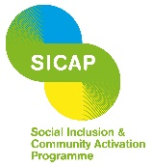

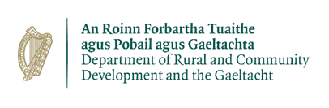
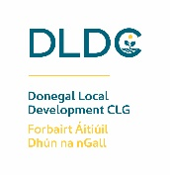
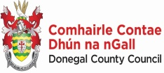
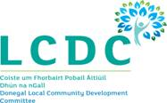

“The Social Inclusion and Community Activation Programme (SICAP) is co-funded by the Government of Ireland, through the Department of Rural and Community Development and the Gaeltacht, and the European Union”
For more information, please visit http://eufunds.ie

